**NCYS ASSIGNMENT 2**

**22K-4675**

**BCY-6A**

**PART 1: -**Using differential privacy technique for numerical columns.

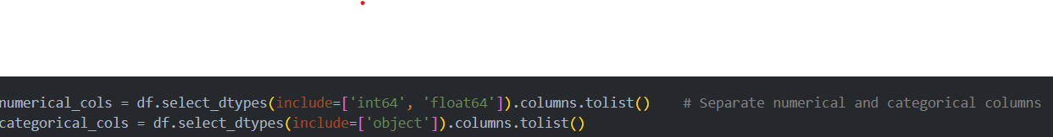

**PART 3: -** Using K-anonymity strategy for string columns

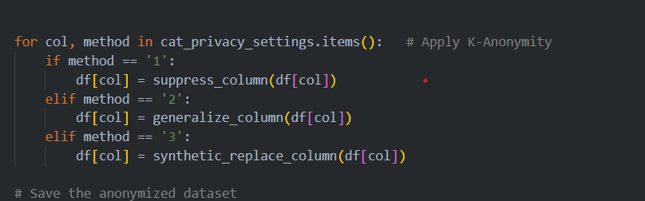

**PART 4:**  User control over string column to decide between Suppression, Generalization or Synthetic Replacement.

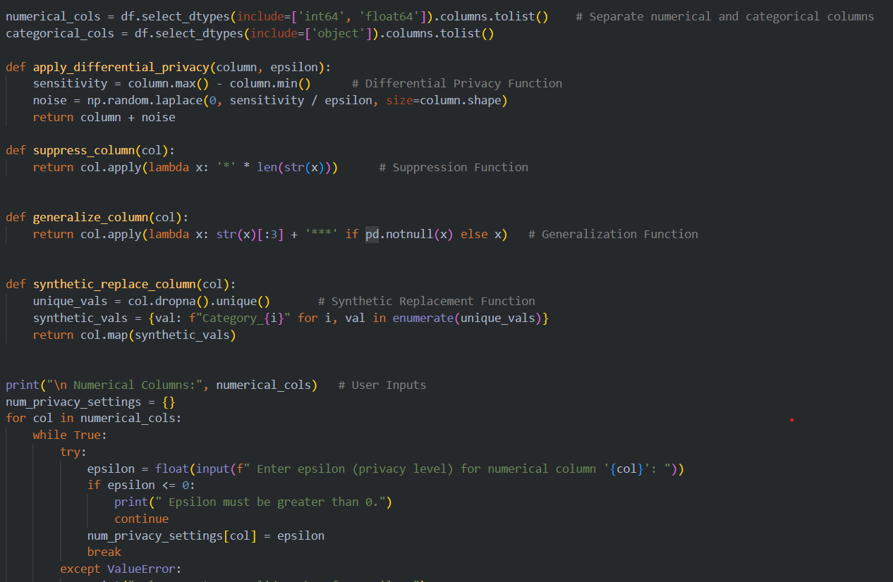

**Summary of what I did: -**

The task for this project is to anonymize the 'Pakistan Housing' dataset to preserve sensitive data and keep it useful for analysis. Numerical attributes are anonymized through Differential Privacy, and users can specify personalized privacy settings (epsilon values). There are K-Anonymity methods available for anonymizing the categoric attributes, such as suppression, generalization, or synthetic replacement. The software preserves data relevance for analysis while satisfying privacy obligations